- A Messaging System is responsible for transferring data from one application to another, so the applications can focus on data, but not worry about how to share it.
- Distributed messaging is based on the concept of reliable message queuing. Messages are queued asynchronously between client applications and messaging system.
Two types of messaging patterns are available − one is point to point and the other is publish-subscribe (pub-sub) messaging system.
Most of the messaging patterns follow pub-sub.
- Point to point messaging system: In a point-to-point system, messages are persisted in a queue. One or more consumers can consume the messages in the queue, but a particular message can be consumed by a maximum of one consumer only. Once a consumer reads a message in the queue, it disappears from that queue. The typical example of this system is an Order Processing System, where each order will be processed by one Order Processor, but Multiple Order Processors can work as well at the same time. The following diagram depicts the structure.
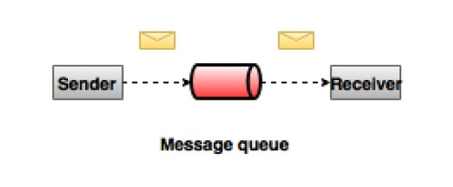

- Publish-Subscribe messaging system: In the publish-subscribe system, messages are persisted in a topic. Unlike point-to-point system, consumers can subscribe to one or more topic and consume all the messages in that topic. In the Publish-Subscribe system, message producers are called publishers and message consumers are called subscribers. A real-life example is Dish TV, which publishes different channels like sports, movies, music, etc., and anyone can subscribe to their own set of channels and get them whenever their subscribed channels are available.
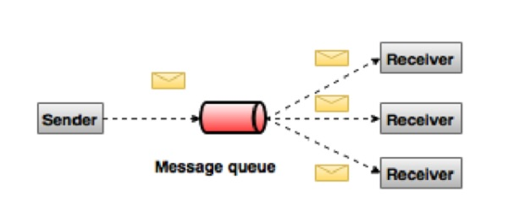

- En

